A Project Report on

**AR/VR Based Comprehensive Framework For Virtual**

**Convocation**

Submitted in partial fulfillment of the requirements for the award of the degree of

### Bachelor of Engineering

in

### Information Technology

by

### Nilay Udeshi (18104015)

Under the Guidance of

### Prof. Neha Deshmukh



#### Department of Information Technology

**NBA Accredited**

A.P. Shah Institute of Technology G.B.Road,Kasarvadavli, Thane(W), Mumbai-400615

UNIVERSITY OF MUMBAI

#### Academic Year 2021-2022

**Approval Sheet**

This Project Report entitled ***“AR/VR Based Comprehensive Framework for Virtual Convocation”*** Submitted by  ***“Nilay Udeshi” (18104015)*** is approved for the partial fulfillment of the requirement for the award of the degree of ***Bachelor of Engineering*** in ***Information Technology*** from ***University of Mumbai*** .

Prof. Neha Deshmukh Guide

Prof. Kiran Deshpande

Head Department of Information Technology

Place: A.P.Shah Institute of Technology, Thane Date:

### CERTIFICATE

This is to certify that the project entitled ***“AR/VR Based Comprehensive Framework for Virtual Convocation”*** submitted by  ***“Nilay Udeshi” (18104015)*** for the partial fulfillment of the requirement for award of a degree ***Bachelor of Engineering*** in ***Information Technology*** ,to the University of Mumbai,is a bonafide work carried out during academic year 2021-2022.

Prof.Neha Deshmukh

Guide

Prof. Kiran Deshpande Dr. Uttam D.Kolekar

Head Department of Information Technology Principal

External Examiner(s) 1.

2.

Place: A.P.Shah Institute of Technology, Thane Date:

### Acknowledgement

We have great pleasure in presenting the report on **AR/VR Based Comprehensive Framework for Virtual Convocation.** We take this opportunity to express our sincere thanks towards our guide **Prof. Neha Deshmukh** Department of IT, APSIT thane for providing the technical guidelines and suggestions regarding line of work. We would like to express our gratitude towards his constant encouragement, support and guidance through the development of the project.

We thank **Prof. Kiran B. Deshpande** Head of Department, IT, APSIT for his encouragement during the progress meeting and providing guidelines to write this report.

We thank **Prof. Vishal S. Badgujar** BE project coordinator, Department of IT, APSIT for being encouraging throughout the course and for guidance.

We also thank the entire staff of APSIT for their invaluable help rendered during the course of this work. We wish to express our deep gratitude towards all our colleagues of APSIT for their encouragement.

**Student Name: Nilay Udeshi**

**Student ID: 18104015**

**Declaration**

We declare that this written submission represents our ideas in our own words and where others’ ideas or words have been included. We have adequately cited and referenced the original sources. We also declare that We have adhered to all principles of academic honesty and integrity and have not misrepresented or fabricated or falsified any idea/data/fact/source in our submission. We understand that any violation of the above will be cause for disciplinary action by the Institute and can also evoke penal action from the sources which have thus not been properly cited or from whom proper permission has not been taken when needed.

———————————————

(Signature)

———————————————

(Nilay Udeshi and 18104015)

Date:

#### Abstract

In this pandemic, people have not been able to celebrate their achievements and accomplishments with their friends and family. One of those achievements is the convocation/graduation ceremony of the students who have successfully invested their hard-work and dedication for achieving this prestigious milestone. A physical graduation ceremony restricts the number of people who can be invited. Limited hall capacity, limited seating and catering don’t allow students to invite all those they would like to join in on their special day. A virtual convocation ceremony allows students to invite as many family members as they would like. Their family could be in any part of the world, but they wouldn’t miss this special day. Live broadcasting to remote audiences and on-demand post-event sessions truly ensures no one is left behind, be it students, parents or their families and friends. At times, students go back to their home country and are unable to come back for their graduation ceremonies. This also helps them attend and make memories with their friends, batchmates and family. This is where the project idea comes into play, where a cross-platform app will be made that will be able to provide a real life environment to the students and their family members where they will be able to enjoy the convocation ceremony without breaking any social distancing norms. To fight this modern era problem,Unity3d and other softwares like Blender, Mixamo, After-effects tools have been used. To achieve this goal, softwares like unity3d will be used, which will help us to create real-life models of students and faculty members. Unity3D software is essential for creating unique and entertaining games, as well as creating responsive graphics and providing a more visual world. Unity3D makes use of OpenGL to ren-der 3D graphics. to create the 3d models of the students and the dignitaries. To further improve the project, softwares like Blender, Illustrator, Auditions tool, after-effects which will help make the environment more interactive and realistic. The project focuses on an idea where every student’s character will be created and after their name is being called during the ceremony, their respective character will walk onto the stage and collect the medal and certificate on the student’s behalf. The project focuses on presenting a framework for evaluating the quality of synchronous virtual graduation events, as well as highlight their and future research areas.

# Contents

|  |  |  |
| --- | --- | --- |
| **1 Introduction**  1.1 Section . . . . . . . . . . . . . . . . . . . . . . . . . . . . . . . . . . . . . . . . . . . . . . . . . . . . . . . . . . . . .5 |  | **5** |
| 1.1.1 Key Objectives . . . . . . . . . . . . . . . . . . . . . . . . . . . . . . . . . . . . . . . . . . . . . .6 |  |  |
| **2 Literature Review** |  | **7** |
| **3 Project Design**  3.1 System Architecture . . . . . . . . . . . . . . . . . . . . . . . . . . . . . . . . . . . . . . . . . . . . . . . . 8 |  | **8** |
| 3.2 UML Diagrams . . . . . . . . . . . . . . . . . . . . . . . . . . . . . . . . . . . . . . . . . . . . . . . . . . . . 9 |  |  |
| 3.2.1 Activity Diagram . . . . . . . . . . . . . . . . . . . . . . . . . . . . . . . . . . . . . . . . . . . . . 10 |  |  |
| 3.2.2 Use Case Diagram . . . . . . . . . . . . . . . . . . . . . . . . . . . . . . . . . . . . . . . . . . . 11 |  |  |
| 3.2.3 Sequence Diagram . . . . . . . . . . . . . . . . . . . . . . . . . . . . . . . . . . . . . . . . . . 12 |  |  |
| **4 Project Implementation**  4.0.1 Design Implementation . . . . . . . . . . . . . . . . . . . . . . . . . . . . . . . . . . . . . . . .13 |  | **13** |
| **5 Testing**  5.1 Functional Testing . . . . . . . . . . . . . . . . . . . . . . . . . . . . . . . . . . . . . . . . . . . . . . . 14 |  | **14** |
| 5.1.1 Unit Testing . . . . . . . . . . . . . . . . . . . . . . . . . . . . . . . . . . . . . . . . . . . . . . . . 15 |  |  |
| 5.1.2 Integration Testing . . . . . . . . . . . . . . . . . . . . . . . . . . . . . . . . . . . . . . . . . . 16 |  |  |
| 5.2 Non-Functional Testing . . . . . . . . . . . . . . . . . . . . . . . . . . . . . . . . . . . . . . . . . . . . . 17 |  |  |
| 5.2.1 Compatibility Testing . . . . . . . . . . . . . . . . . . . . . . . . . . . . . . . . . . . . . . . . 18 |  |  |
| **6 Result** |  |  |
| **7 Conclusions and Future Scope** |  | **26** |
| **Appendices**  Appendix-A . . . . . . . . . . . . . . . . . . . . . . . . . . . . . . . . . . . . . . . . . . . . . . . . . . . . . . . . . . . . 28 |  | **27** |
| **Publication** | **32** |  |

**List of Figures**

* 1. Flow Diagram 4
  2. Activity Diagram 7
  3. Use Case Diagram 8
  4. Sequence Diagram 8
  5. Convocation Hall 12

1. Dignitaries on the stage 12

4.1 Female Character Model 13

4.2 3d models of the characters 14

4.3 Code snippet for walking animation 15

4.4 Code snippet for Character movement 16

4.5 Code snippet for Character rotation 17

**List of Abbreviations**

* Ai- artificial intelligence
* Tpcm- Third person character movement
* 3d - Third dimensional
* Vs code - Visual Studio Code
* AR - Augmented reality
* VR - Virtual Reality
* Scifi - Science Fiction

# Chapter 1

**Introduction**

Virtual platforms Like Zoom, Cisco WebEx, Microsoft teams have proved to be very useful for conducting meetings and conferences during this pandemic situation as people are not able to meet each other in person for such occasions. The graduation ceremony is not available to many online learners and thus they cannot commemorate this important milestone. It starts by assessing the literature on virtual graduations and creating a typology of several graduation models used by higher education institutions today. As a solution, the idea aims to develop an interactive system that will help colleges to conduct a convocation ceremony for their students in an orderly and effective way. A virtual graduation ceremony is a graduation ceremony that takes place on an online event platform. It has a virtual environment that resembles a real-life commencement ceremony where students are awarded their academic diplomas or degrees. Online graduation ceremonies ensure that your graduating students have a memorable day. If the virtual environment replicates the physical one it can instantly bring your event to life. Therefore we have user-friendly 3D designs, a venue modelled, custom landing and registration pages, animated graduate avatars, and a help desk. In this AR/VR Based Comprehensive Framework for Virtual Convocation, the main focus is to supply a platform to enjoy the ceremony virtually alongside being user-friendly. So, to achieve the mentioned objectives, it was decided to use Unity3d software for the environment development, VS-code for basic C- sharp coding, Autodesk, 3ds Max for creating and animating 3d models and audition tool for audio purposes. Creating a cross-platform environment is the primary goal of this project. This will help the graduates be engrossed in the ceremony. This project is about creating a real life experience for the students who are not able to attend their graduation ceremony. The basic hierarchy includes a ceremony hall designed in Unity-3D engine. The students are able to absorb all attention of the ceremony and enjoy the prestigious moment of the life. So creating this virtual convocation ceremony begins with designing a ceremony hall, followed by character design and modelling and providing 3D effects to make it more realistic.

**Key Objectives**

1. To build a Virtual platform (application) for pc/mobile using Unity 3d engine along with some coding.

2. To efficiently handle multiple users at a time so that students can enjoy convocation ceremony without

any interruption.

3. To make the app as user friendly as possible for all kinds of users.

4. To try to provide the option to download the e-certificate during the ceremony

# Chapter 2

# Literature Review

**“Introduction to IEEE Virtual Reality 2020 Special Issue”**

Authors: K.Mueller and D.Bowman

Findings:  
The author discussed the various aspects of virtual reality, its various advantages, and its usage in various engineering sectors. They discussed how virtual reality can help improve the quality of work and provide a better environment for engineers. VR is an immersive environment that uses 3D technology. Virtual reality is a technology in which computer-generated images are used to create a virtual universe. However, it is not a substitute for real-time teaching and learning. It is widely used in education to improve the efficiency and effectiveness of teaching. VR classroom has become an integral part of education. This paper presents an overall integration solution that combines VR composition with its various features.

**“Virtual Reality as an Education Tool”**

Authors: Roudaina Houjeir, Kristian Gotthelf

Findings:

The author has focused on the significant importance and usage of virtual reality in the engineering sector like design, manufacturing, inspection, tooling, assembly, prototyping, etc. In this, virtual reality has been defined as an emerging technology that can provide the user with an actual working environment.

**“Research of VR Modeling based on VRML and 3dsMAX”**

Authors: Wei Shen and Wenqi Zeng

Findings:

The author has focused on the three-dimensionality of Virtual Reality structure. Virtual reality stands apart from other representational technologies because of its unique properties of immersion, presence, and interactivity. Virtual reality does not mimic actual life and does not serve as a representational tool. A human being has the inability to distinguish between perception, hallucination, and illusions. VR has grown into a new phase and becomes a distinct field in the world of computing. The use of virtual reality in automotive design, robot design, medicine, chemistry, biology, education, and building design and construction has already been investigated.

**Chapter 3**

**Project Design**

**3.1 System Architecture**

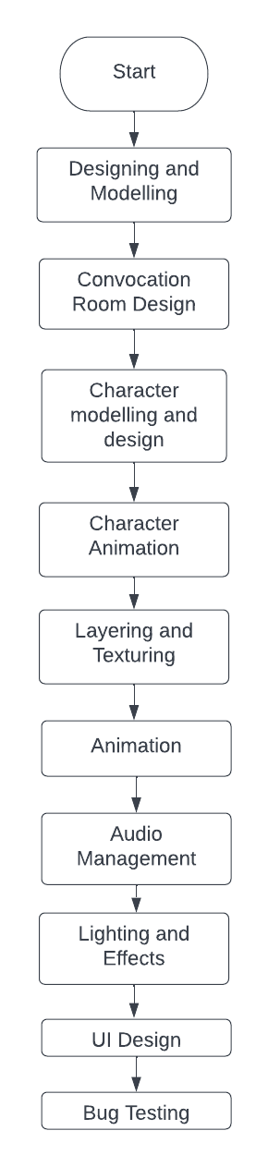

Figure 3.1: Flow Diagram

## UML Diagrams

### Activity Diagram

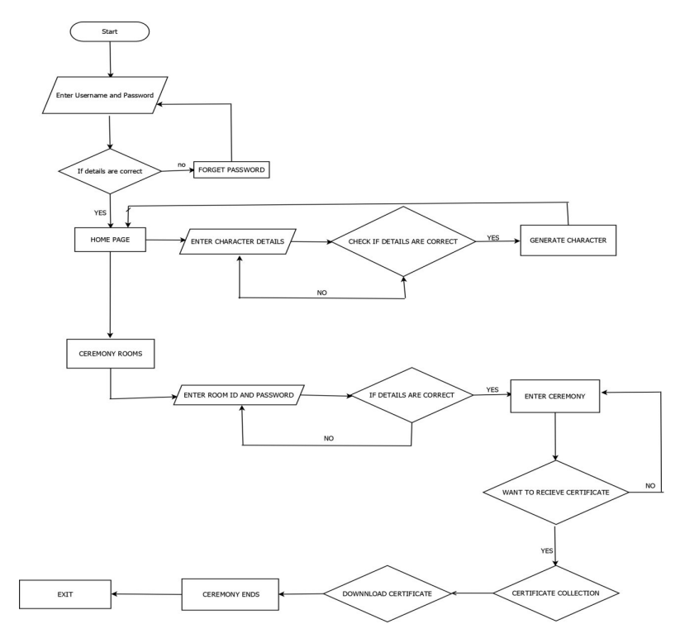

Figure 3.2: Activity Diagram

### 3.1.2 Use Case Diagram

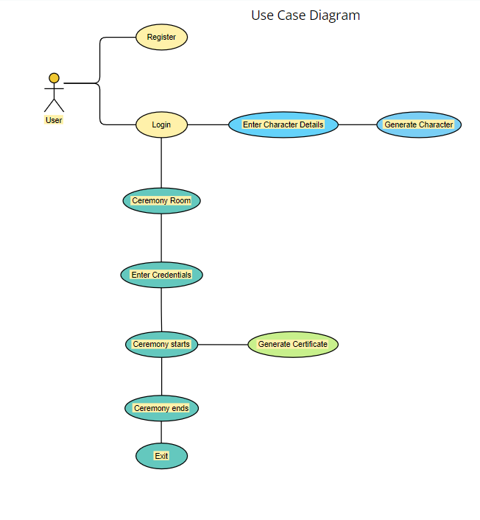

Figure 3.3: Use Case Diagram

### 3.1.3 Sequence Diagram

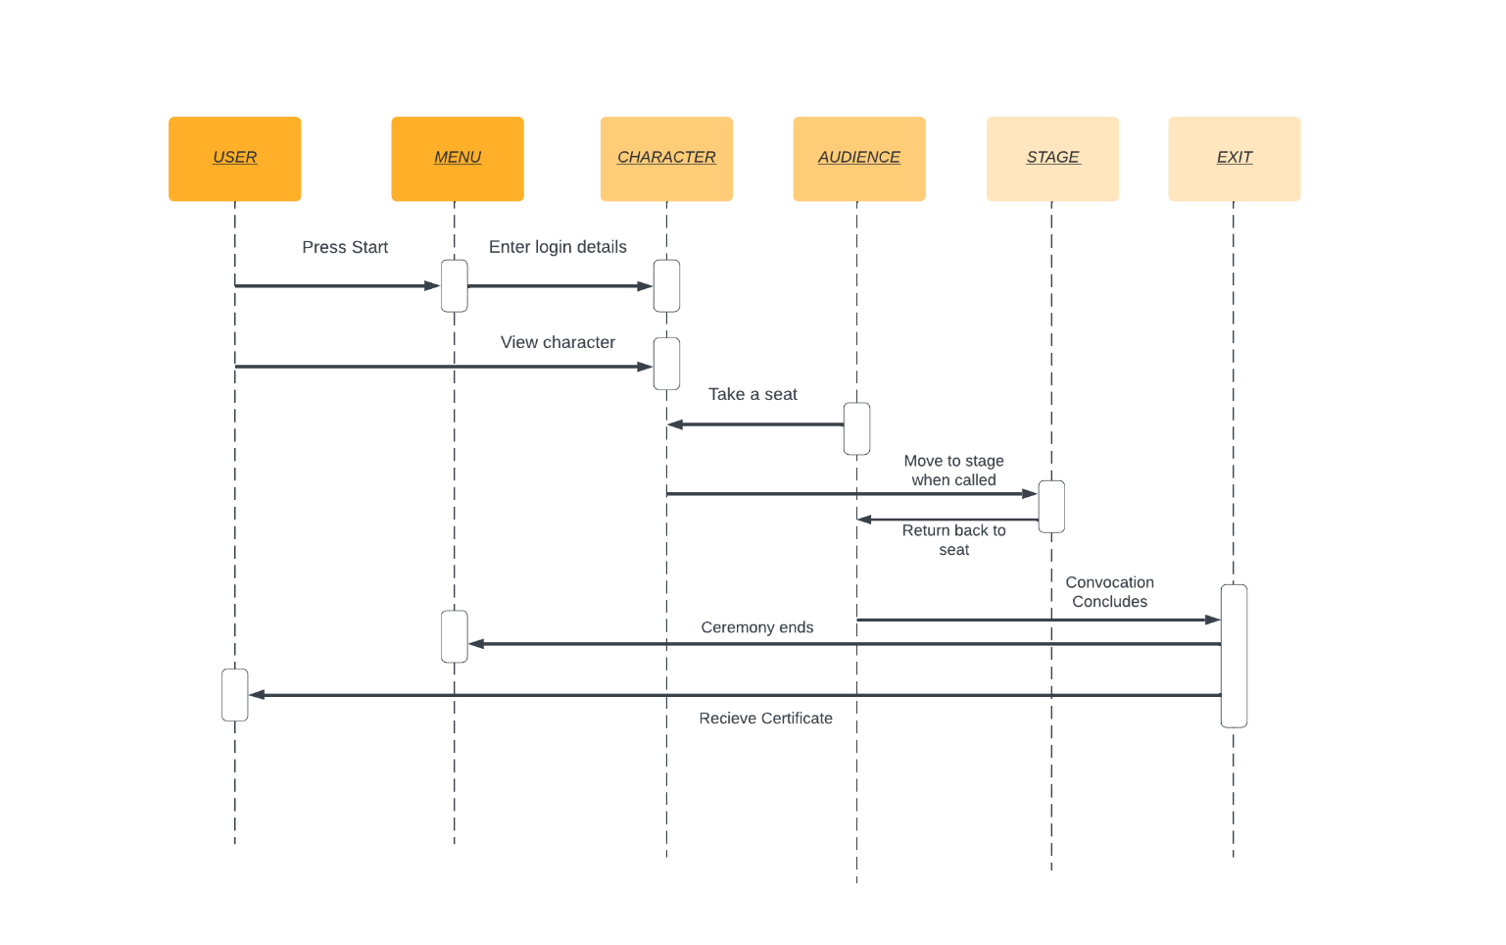

Figure 3.4: Sequence Diagram

# Chapter 4

**Project Implementation**

1. Making a project and a scene view: At first, select "create a new project" in Unity Hub and Select the unity version installed on our device. When the unity editor starts, it already has an empty scene view is created, which includes a camera and directional lighting.

2. Importing Unity assets: Unity assets make it easier to work on any given project. Many assets contain predefined textures, materials, scripts, etc., which usually saves time creating each asset individually. We can consider assets like libraries used to make our project. The work is straightforward and quick asset packages which we used are: standard asset pack, 3D Scifi Kit. We also made use of individual assets such as chairs and round tables podium, stage, flower-pot, notepad, etc.

3. Creating a convocation hall: Using predefined rectangular objects, we can create walls, ceiling and floor of the hall. After setting up the required objects, we can add textures and materials for them from imported assets or create new material in the editor.

4. Placing objects inside the hall: Place chairs and tables as per requirements and add materials.to them. Next, use a cuboid object to make the stage and place a podium at its left corner. Suppose if necessary decorate the hall using flowerpots, designer lamps, etc.

5. 3D model creation in 3ds Max or Blender: Create models of faces using the basic tools and then Add it to any predefined human body. After completion of the basic human models (male and female).We need to add rigging to the model so that we can control its movement. Finally in the skinning process we add materials, mesh, and skin to our 3D model. Import the.obj file to Unity and then we can use them in our unity editor.

6. Animating your characters: For animation we have used animator controller on our model along with some predefined scripts like Ai-controller, third person controller, etc. We have added walking , handshake ,breathing, talking, etc animations to our characters. Finally when all scripting work is completed , we created clips and animated a whole convocation ceremony along with recorded audio clips.

7. Building Final application: When testing and implementation process is completed, using build option in file menu, we built our project for Windows OS and android and then connected the database which stores user information after login.

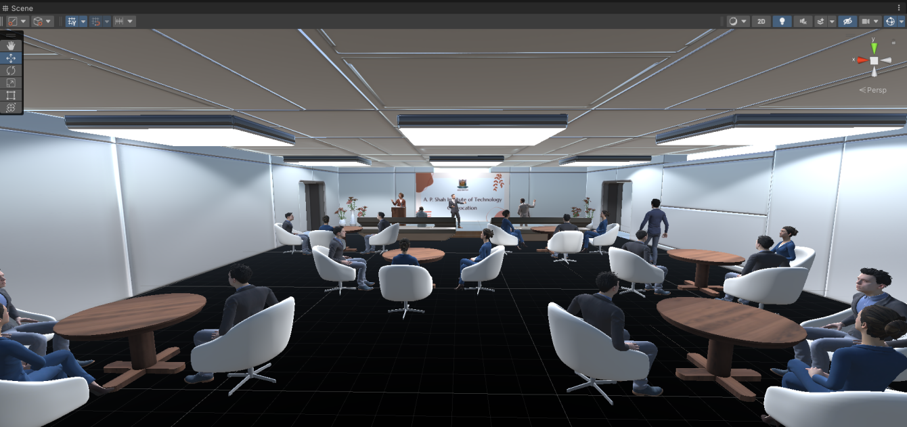

Fig 1: Convocation Hall

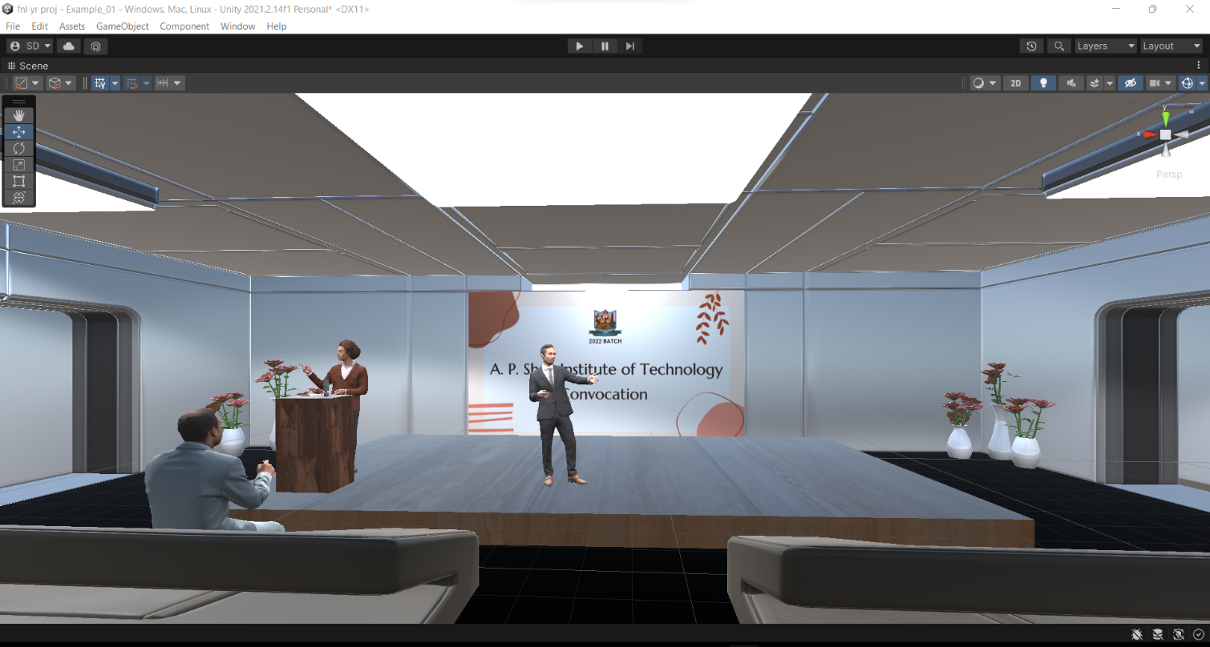

Fig 2: Dignitaries on stage

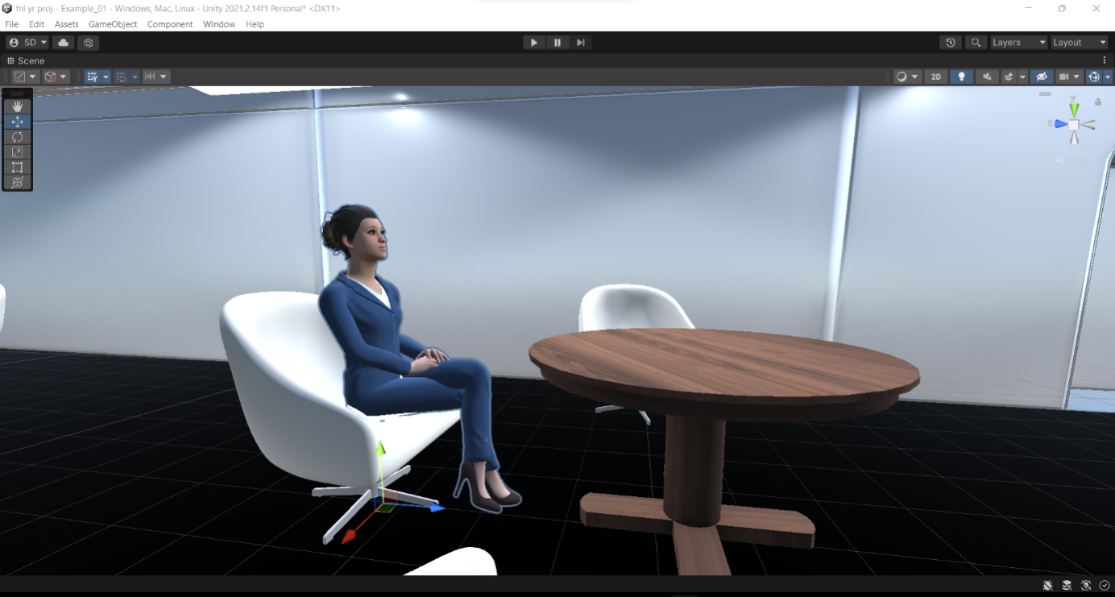

Fig 3: Female Character Model

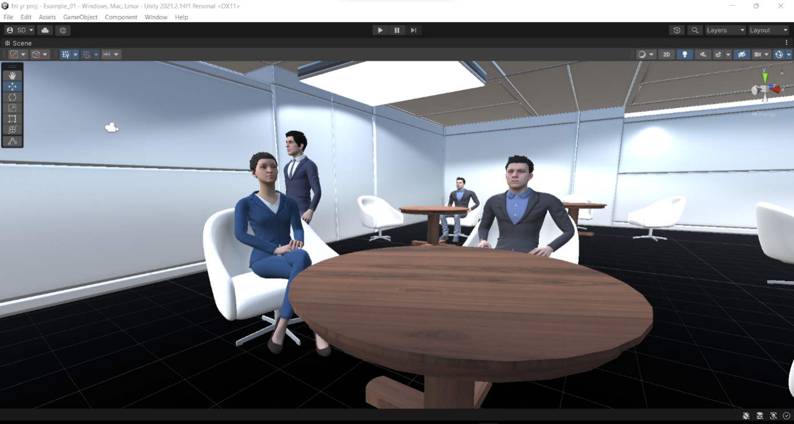

Fig 4: 3d models of the characters

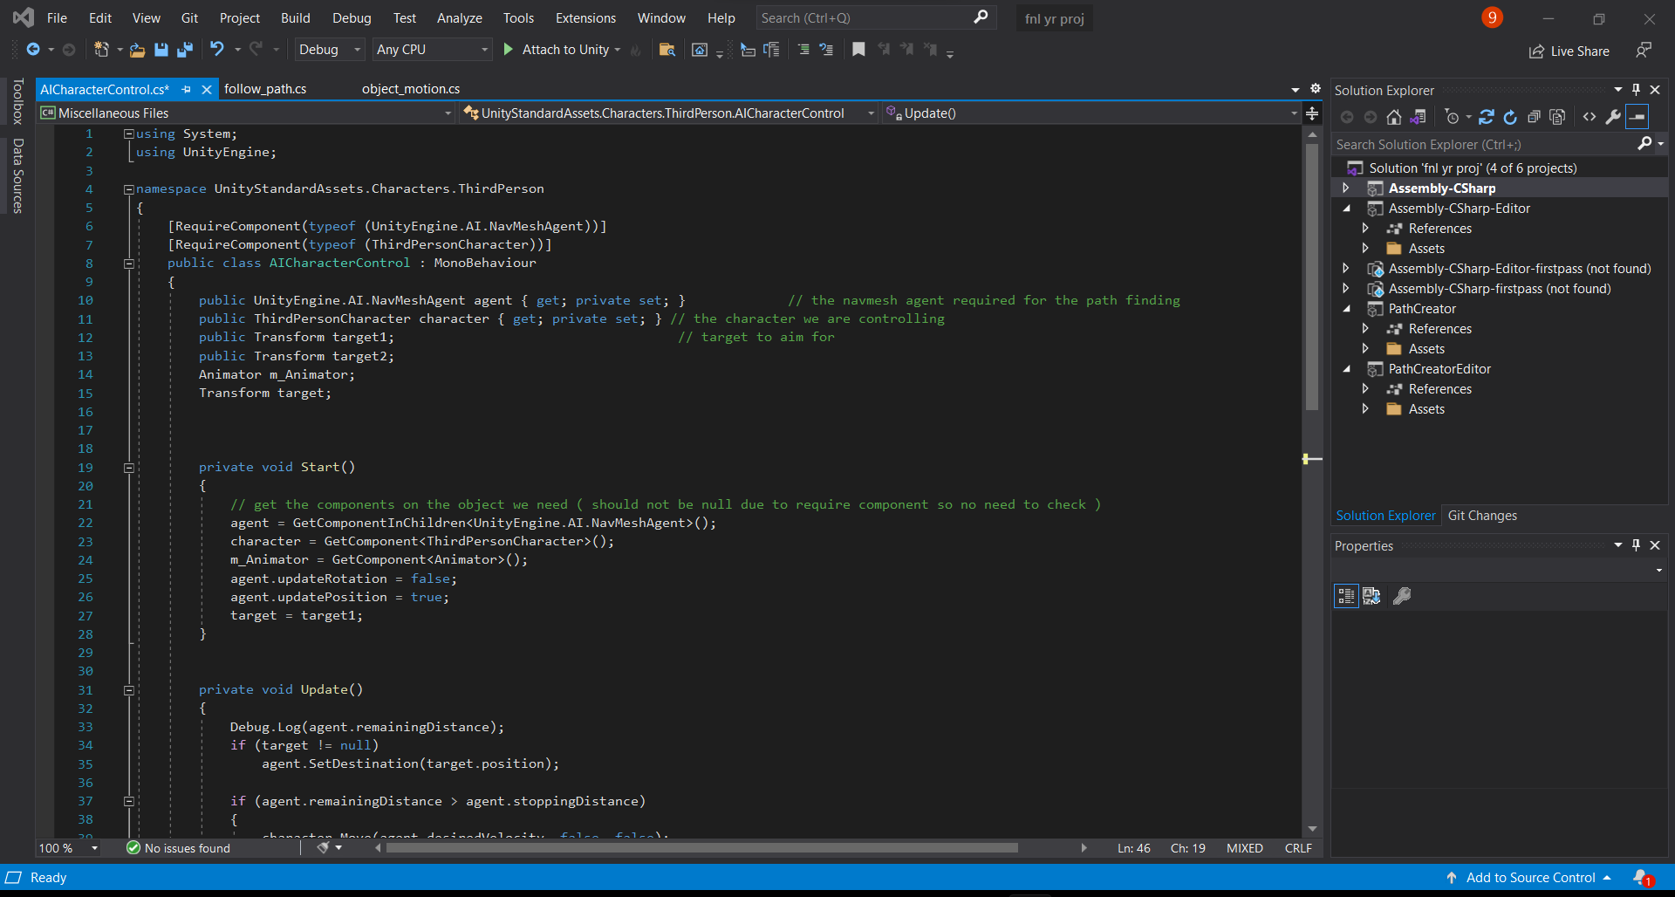

Fig 5: Code snippet for walking animation

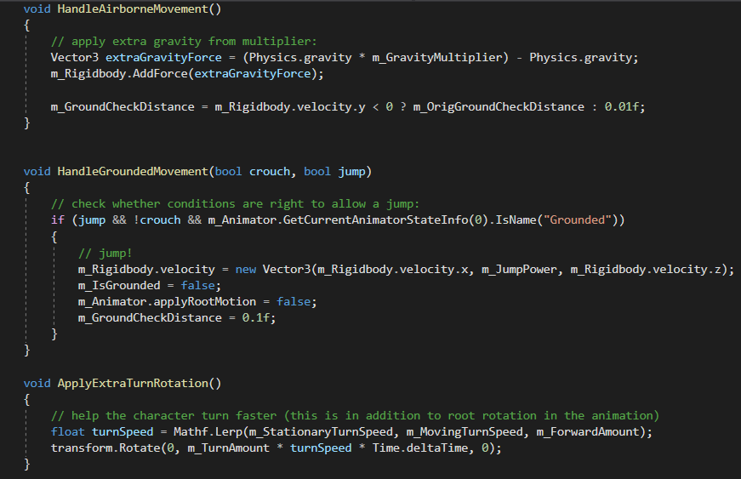

Fig 6: Code snippet for Character movement

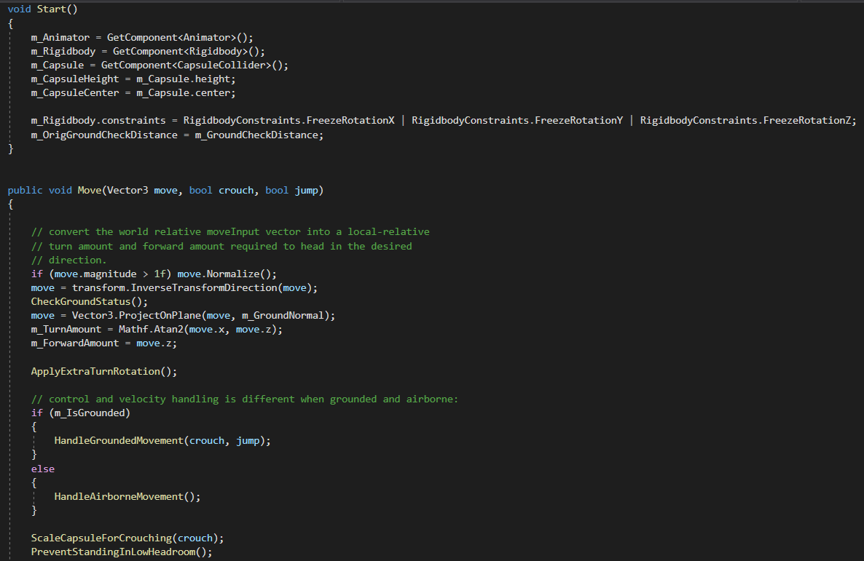

Fig7: Code snippet for Character rotation

# Chapter 5

# Testing

# 5.1 Functional Testing

### Unit Testing

Unit testing is the first level of testing, which is typically performed by the developers themselves. At the code level, it is the process of verifying that individual components of software are functional and perform as intended. Developers will often write and execute tests before handing the product or feature to the test team in a test-driven environment.

Unit testing may be done manually, however automating the process will reduce delivery times and boost test coverage. Because flaws will be detected sooner in the testing process and will take less time to repair than if they were discovered later, debugging will be easier as a consequence of unit testing.

Unit testing is the most suited software approach for our application. At this point, we started creating code in the form of units, such as player movement, opponent movement. Each module was also tested independently so that we could simply comprehend each sample and spot any issues. It helped us understand the expected output of each module, which we had separated into discrete components.

### Alpha Testing

It is a type of validation testing which is done before the product is launched to the customers. So, before

the software is launched to the customers, internal testing of the software is done by us to make sure there

are no flaws in the software.

## Non-Functional Testing

Compatibility testing assesses how well an application or piece of software will work in a variety of situations. It's used to determine if your product is compatible with a number of operating systems, platforms, and resolutions. The objective is to guarantee that the functionality of your product is consistently supported in any environment that your end customers are likely to experience. Unity Engine is the software we're using. It's open-source software that allows you to make, design, and develop 2D and 3D games. We ensured that our gaming application was compatible with all operating systems. This application is compatible with a wide range of operating systems.

# Chapter 6

# Result

Being an interactive project ,all the students who will be participating in their virtual convocation ceremony, will be seated in the audience. Once the ceremony starts, announcements regarding the students name along with their respective roll numbers and marks will be made. As soon as the names are announced, the 3d models will get up from their seats, walk up to the stage and finally get a certificate from the dignitaries who will be on the stage itself. Once the commemoration is done , the model walks back to his/her seat and the ceremony continues. The primary focus of the projects is to create a virtual convocation ceremony for all those people who lost their graduation ceremony due to covid. With this application, students along with their parents, relatives and friends would b able to enjoy their convocation ceremony without breaking any social distancing norms.

# Chapter 7

**Conclusions and Future Scope**

The pandemic has pressured people to undertake particular techniques with a purpose to preserve themselves secure from the coronavirus. The cause of the venture is to make college students sense the experience of success and satisfaction of graduating whilst making sure their safety. It can also be useful for the students are acquiring distance education. The main focus of this project is to provide a virtual environment using unity and some concepts of virtual reality and augmented reality. IIT Bombay along with its students took a huge step in creating such a platform and encouraging a sense of creating such type of apps. Taking inspiration from the project, we as students from APSIT are trying to create a similar app for our college which would be easy to use and a multi-platform application. Keeping all our constraints in mind we will try to achieve our goal as soon as possible to make this environment available to our college. If the execution of the project is successful then the scalability and make it available for all the departments in the college.

# Bibliography

[1] "Introducing the IEEE Virtual Reality 2020 Special Issue," in IEEE Transactions on Visualization and Computer Graphics, vol. 26, no. 5, by K. Mueller and D. Bowman, pp. iv-v, May 2020, DOI :10.1109/TVCG.2020.2978971.

[2] L. Rosenblum , "Virtual and augmented reality 2020," in IEEE Computer Graphics and Applications, vol. 20, no. 1, pp. 38-39, Jan.- Feb. 2000, DOI : 10.1109/38.814551.

[3] K. Mueller and D. Schmalstieg, "Introducing the IEEE Virtual Reality 2019 Special Issue," in IEEE Transactions on Visualization and Computer Graphics, vol. 25, no. 5, pp. iv-iv, May 2019, DOI : 10.1109/TVCG.2019.2902964.

[4] ”New realities : a systematic literature review on virtual reality and augmented reality” by Yung, Ryan, Khoo-Lattimore, Catheryn, <https://doi.org/10.1080/13683500.2017.1417359>.

[5] Roudaina Houjeir,Kristian Gotthelf , ”The 2016 Dubai ACBSP Region 8 ConferenceAt: Dubai, UAE : Virtual Reality as an Education Tool”.

[6] Z. Pezeshki, A. Soleimani and A. Darabi, ”3Ds MAX to FEM for building thermal distribution: A case study,” 2017 3rd Iranian Conference on Intelligent Systems and Signal Processing (ICSPIS), 2017, pp. 110-115, doi: 10.1109/ICSPIS.2017.8311599.

[7] Wei Shen and Wenqi Zeng, ”Research of VR modeling technology based on VRML and 3DSMAX,” Proceedings of 2011 International Conference on Computer Science and NetworkTechnology, 2011, pp. 487-490, doi: 10.1109/ICCSNT.2011.6182002.

[8] Y. Kuang and X. Bai, ”The Research of Virtual Reality Scene Modeling Based on Unity3D,” 2018 13th International Conference on Computer Science and Education (ICCSE), 2018,pp. 1-3, doi: 10.1109/ICCSE.2018.8468687.

[9] S. Wang, Z. Mao, C. Zeng, H. Gong, S. Li and B. Chen, ”A new method of virtual reality based on Unity3D,” 2010 18th International Conference on Geoinformatics,2010,pp.1- 5,doi:10.1109/GEOINFORMATICS.2010.5567608.

[10] S. L. Kim, H. J. Suk, J. H. Kang, J. M. Jung, T. H. Laine and J. Westlin, ”Using Unity3D to facilitate mobile augmented reality game development,” 2014 IEEE World Forum on Internet of Things (WF-IoT), 2014, pp. 21-26, doi: 10.1109/WF-IoT.2014.6803

# Appendices

**For Unity3d**

1.Overview: The setup wizard is your first step to creating with Unity.

2.Before you begin, check that your computer meets the requirements for Unity. Unity can be installed on Windows and macOS. Support for Linux is in preview, which means that it will work but you might encounter some bugs. There are some minimum system requirements for Unity to run well.

Unity cannot currently be installed on tablets or Chrome OS.

3.Download the setup wizard

1. Go to the Unity download page.

2. Download the Unity Hub, select the option for your operating system. A file will download named UnityHubSetup. This file name might vary depending on the Hub version and your operating system.

4.Install and launch the Unity Hub

1. Locate the UnityHubSetup.exe file you downloaded previously.

2. Launch the UnityHubSetup installer.

3. Follow your platform instructions to install the Unity Hub.

4. Open the Unity Hub application.

5. Choose an install location then select Install to install the Unity Editor.

The opening Install Wizard window, where you need to select an install location.

**For Blender**

Step 1: Visit the Blender Website.

Step 2: Click on the link to access the Download page. Also, select the operating system to install the program.

Run the downloaded Installer

Step 3: Now, Run the downloaded Installer, which will probably be available in the download folder.

Step 4: Now, click on the Next Button to initiate the installation process.

Step 5: Click on the Next Button when asked to move ahead in the process.

Step 6: In this step, the user can change the default location of the program. Click Install to Move ahead.

Step 7: Wait for the Program to Install Blender.

Step 8: Click on Finish and complete the Installation Blender process.

Step 9: After Installing the program, the Blender window will look like this. The interface of Blender is the same across all the operating systems.

Step 10: The software starts with the default screen, and it is divided into five main areas that contain Editors in General.

Step 11: The User Interface of the Program is designed in such a way that helps the user in understanding each tool and feature easily.

Step 12: The User Interface is created very clearly and neatly, that allows the user to view and work on all important options and tools at one glint without moving or pushing the editors in the UI.

Step 13: The users can access the tools easily and effectively. They need not spend time on selecting between the various tools. Blender also uses a lot of keyboard shortcuts to accelerate the work. These keyboard shortcuts can be modified and updated in the Keymap Editor.

# Publication

Paper entitled “**AR/VR Based Comprehensive Framework for Virtual Convocation**” has been accepted by “**International Conference on ICT for Sustainable Development(ICT4SD-Goa)**” by “**Nilay Udeshi, Soham Dhuri, Diya Luniya and Prof. Neha Deshmukh**”.